LEMBAR JAWABAN
ASSIGNMENT REPORT - WEEK 10 (TASK 1)
SEMESTER GENAP TAHUN AJARAN 2025/2026

Mata Kuliah : Internet of Things (IoT)
Kelas : IF601
Prodi : PJJ Informatika
Nama Mahasiswa : Muhammad Ketsar Ali Abi Wahid
NIM : 230401070204
Dosen : Prof. Jong-Dae Park

Jawaban

Step 1: Database Migration & Starting Gunicorn Web Server
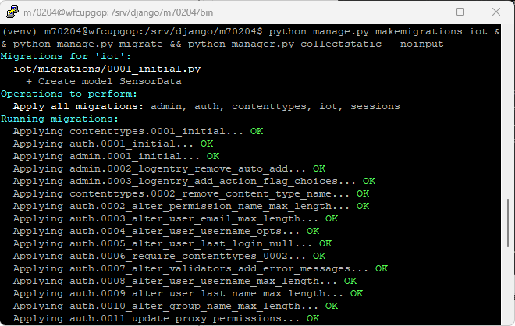
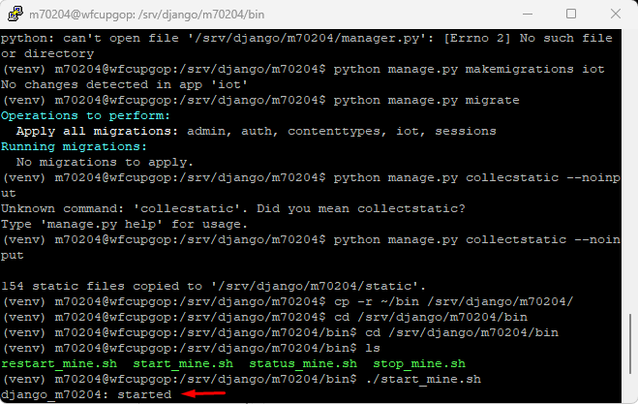
Connected to the server via PuTTY, activated the Python virtual environment (venv), and executed 'python manage.py migrate' to apply database migrations. Ran 'python manage.py collectstatic --noinput' to compile static assets. Finally, copied Gunicorn control scripts and successfully launched the WSGI web server using './start_mine.sh'.

Step 2: Local Simulation Client (send_django_mock_data.py)
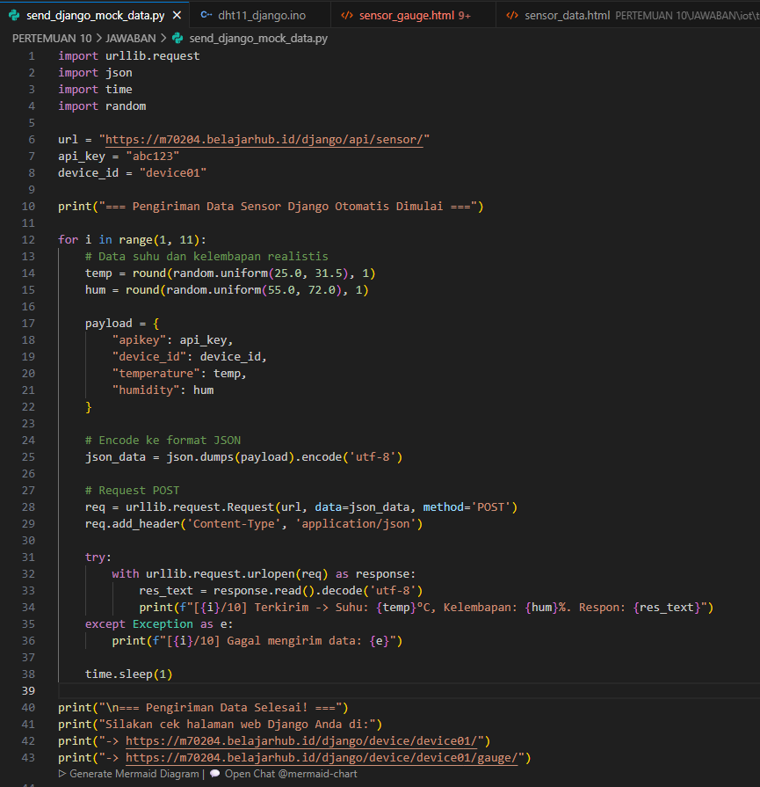
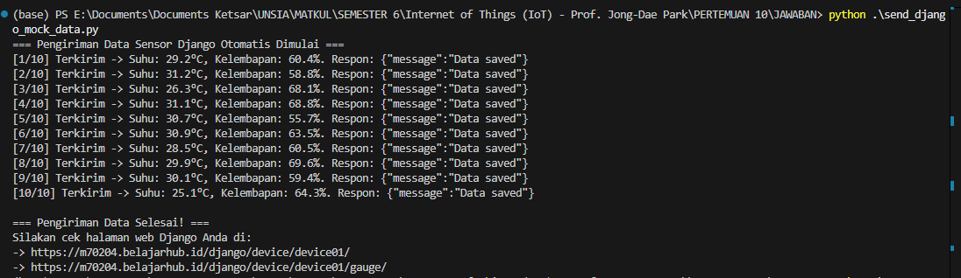
Executed the custom Python automation script 'send_django_mock_data.py' locally. The script successfully formulated JSON payloads for temperature and humidity, sent 10 HTTP POST requests to the Django REST API endpoint at 'https://m70204.belajarhub.id/django/api/sensor/', and received success status responses from the server.

Step 3: Tabular Sensor Log Verification (device_data_view)
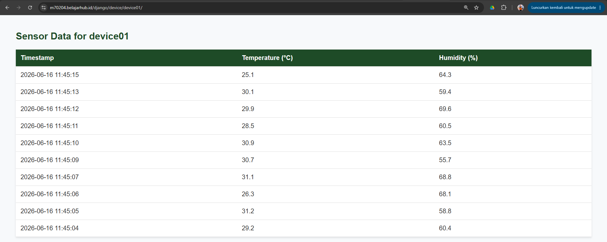

Accessed the Django web application at 'https://m70204.belajarhub.id/django/device/device01/'. The page successfully queried the SQLite database, fetched the 10 recently sent sensor readings, and displayed them in an HTML table containing the correct timestamps, temperatures, and humidity percentages.

Step 4: Live Sensor Gauge Visualization (sensor_gauge_view)
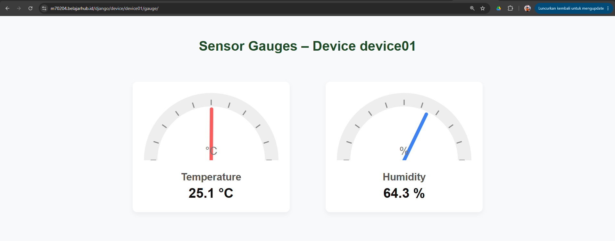
Navigated to the visual gauge display at
'https://m70204.belajarhub.id/django/device/device01/gauge/'. The interface displays two semi-circular gauges representing the latest temperature (25.1 °C) and humidity (64.3 %) telemetry readings, providing real-time visual instrumentation.

Nilai | Tanda Tangan Dosen Pengampu / Tutor | Tanda Tangan  Mahasiswa
 | ( Prof. Jong-Dae Park) |   (Muhammad Ketsar Ali Abi Wahid)
Diserahkan pada Tanggal: |  | Tanggal Mengumpulkan:
12/06/2026 |  | 16/06/2026

